

NAME OF LEARNER:
MATHEMATICS BASELINE TEST: JUNE/ JULY 2020
GRADE 7

MARKS : 20
DURATION : 1 Hour

This test consists of 9 pages, including the cover page.
Instructions and information to the learner
Read the questions carefully
Answer ALL the questions
Circle only the letter for the correct answer, e.g. If the correct answer in 1. is D, you should only circle D
There is only one correct answer in each question
This question paper consists of 5 questions.
Diagrams are NOT drawn to scale

 | Which of the following number sentences is incorrect?
 |  | $5+6-6=6-6+5$
 |  | $5×6=6×5$
 |  | $5+6=6+5$
 |  | $5÷6=6÷5$
 | What is $2+3×\left(10-6\right)$?
 |  | 44
 |  | 28
 |  | 20
 |  | 14
 | What is $\frac{5}{6}$ of 600?
 |  | 3 000
 |  | 611
 |  | 500
 |  | 5
 | What is the value of $\frac{3}{4}+\frac{5}{12}$?
 |  | $\frac{8}{16}$
 |  | $\frac{8}{12}$
 |  | $\frac{14}{12}$
 |  | $\frac{12}{24}$
Bongi wants to join three pipes of the same width.
The lengths of the pipes are 3$\frac{3}{4}$ m, 5$\frac{1}{2}$ m and 4$\frac{7}{8}$ m. How long will the pipe be after joining the three pipes?

 |  | 12$\frac{11}{14}$
 |  | 12$\frac{17}{24}$
 |  | 13$\frac{3}{8}$
 |  | 14$\frac{1}{8}$
What is the number indicated by A on a number line below?
A
4,12
4,2

 |  | 4,10
 |  | 4,08
 |  | 4,80
 |  | 4,06
What should be done to 0,01 to get 1?
0,01
1

 |  | $+0$
 |  | $×1$
 |  | $×10$
 |  | $×$100
 | What is 54,73$+$ 22,4 =?
 |  | 76,113
 |  | 76, 14
 |  | 76, 77
 |  | 77,13
 | Which decimal fraction is equivalent to $\frac{2}{5}$?
 |  | 0,2
 |  | 0,3
 |  | 0,4
 |  | 0,5
What is the value of ∆ in the number sentence below?
3 ∆ + 2 = 8

 |  | 4
 |  | 3
 |  | 2
 |  | 1
What is the missing number in the sequence?

2; 4; 16; ……..
 |  | 256
 |  | 64
 |  | 32
 |  | 18
What is the rule that describes the pattern below?

Input | 1 | 2 | 3 |  | 10
Output | 6 | 13 | 20 |  | 69

 |  | Output $+ 7$
 |  | Input $× 5+1$
 |  | Input $×6+ 0$
 |  | Input $× 7 – 1$
In the pattern below, the diagram with two shaded squares has six unshaded triangles.
If the pattern continues to grow, how many triangles are there in a diagram with five shaded squares?

 |  | 9
 |  | 10
 |  | 12
 |  | 15
 | Which transformation shows reflection of letter A below?
On the grid below, each block represents 1 cm by 1 cm. ABCD is a rectangle.
Line AC is joined such that ABCD is a triangle. What is the area of triangle ABC?
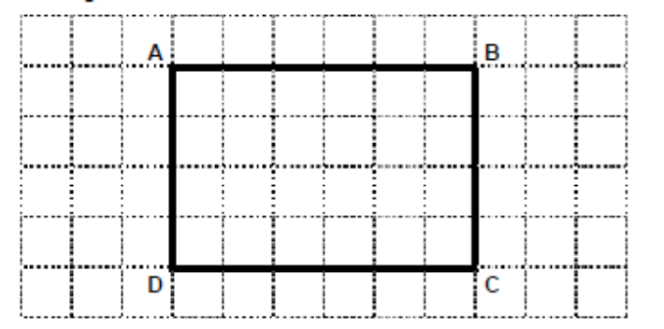

 |  | 24 cm²
 |  | 20 cm²
 |  | 12 cm²
 |  | 10 cm²
 | Which of the statements is correct about rectangles with equal areas?
 |  | The shorter the breadth/ width of the rectangle, the bigger the perimeter.
 |  | The longer the length of the rectangle, the smaller the perimeter.
 |  | Rectangles with equal areas have different permeters
 |  | Rectangles with equal areas have equal perimeters.
What is the volume of the figure below?

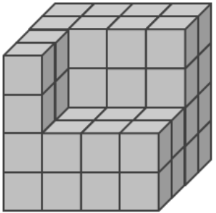

 |  | 64 cubes
 |  | 52 cubes
 |  | 32 cubes
 |  | 16 cubes
 | The graph below shows different modes of transport used by learners when they go to school.
 | What fraction of learners use cars to school?
 |  | $\frac{2}{5}$
 |  | $\frac{3}{5}$
 |  | $\frac{2}{3}$
 |  | $\frac{1}{3}$
 | Which of the following statements is true about the graph in 18?
 |  | The number of learners who travel to school by cars is twice the number of learners who ride bicycles to school.
 |  | The number of learners who travel to school by cars is twice the number of learners who walk to school.
 |  | Most parents prefer to drive their children to school.
 |  | Most learners walk to school.
What is the median of the data below?

18; 15; 9; 15; 17; 17; 11; 18; 15; 19.

 | A | 17
 | B | 15
 | C | 16
 | D | 19

